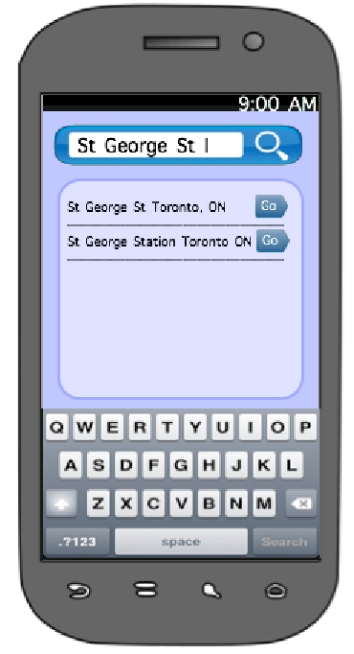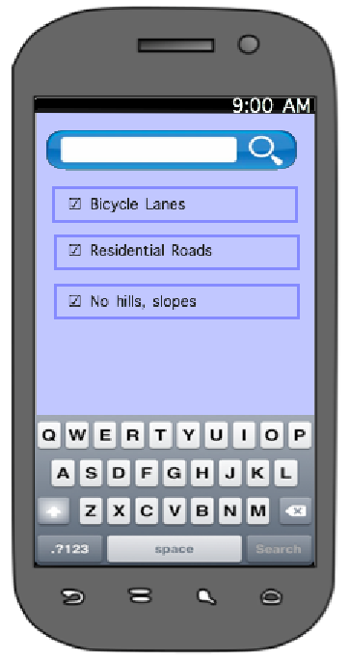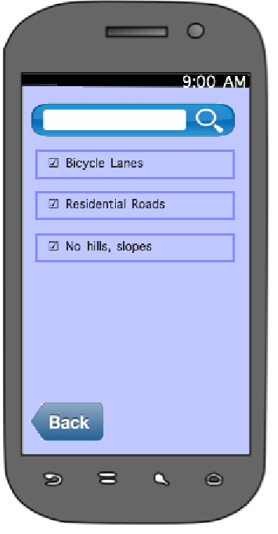

Application will generate closest match based on their current location. Users can select these options for further detail .Note that the back button is hidden under the keyboard.

From the Main Menu, user will be given checkboxes to filter their most preferred types of travel.

Touch-screen keyboard to input designated route in search box.

**GPS technology enabled**

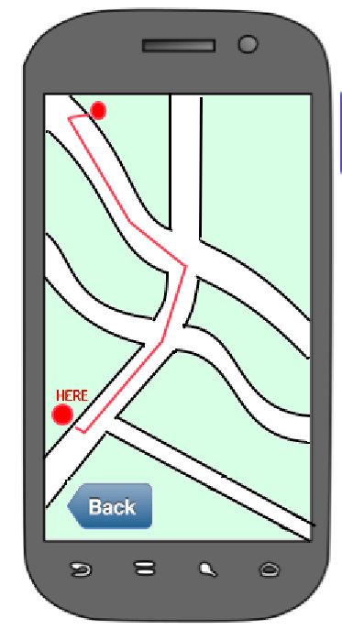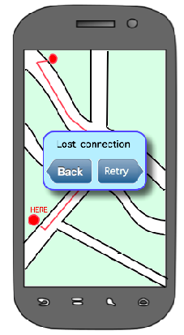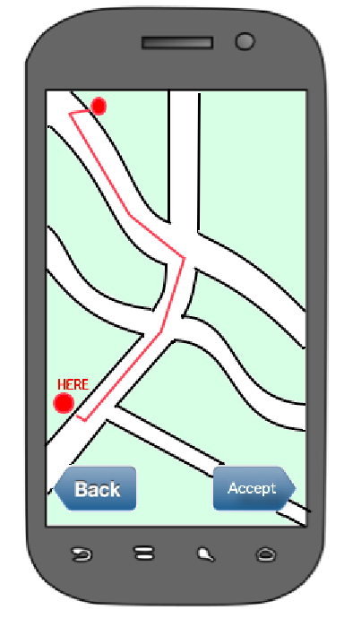

When the application loses connection, either cache the map or retry to regain connection.

**Communicates**

**Wirelessly**

User accepts suggested route. Application will wirelessly send signal to device on user or bike, indicating whether to turn left or right.

Technology on user or mounted on bike.

Preview of suggested route. Users can either accept or go back and view another route.